UNITED NATIONS OFFICE AT GENEVA

Security Registration Form
Please Print
Title of the Conference Date __________________________________
Second Preparatory Meeting in advance of the Review Conference of States Parties to the Mine Ban Treaty
28 -29 June 2004, Palais des Nations, Geneva
Organization or Agency
Participant
Mr. Family Name First Name

Mrs.

Ms.

Participation Category
Head of Delegation Observer Organization

Are you based in Geneva as a representative of your permanent mission ?

YES NO (delete non applicable)
Delegation Member NGO (ECOSOC Accred.)

Observer Country Other (Please Specify Below)

…
Participating From / Until
28 June 2004
29 June 2004
Document Language Preference English French Other ___________________

Official Occupation (in own country) Passport or ID Number Valid Until

Official Telephone N°. Fax N°. E-mail Address

Permanent Official Address

Address in Geneva

Accompanied by Spouse Yes No

Family Name (Spouse) First Name (Spouse)

On Issue of ID Card
Participant Signature

Spouse Signature

Date

Participant photograph if form is sent in advance of the conference date.

Please PRINT your name on the reverse side of the photograph

Spouse photograph if form is sent in advance of the conference date.

Please PRINT your name on the reverse side of the photograph
Security Use Only

Card N°. Issued

Initials, UN Official

Please go first to Security Identification Section
ENTRY/EXIT CARS AND PEDESTRIANS
You will have your entrance badge if you have already registered
Open 08h00 – 17h00 non stop
SALLE DES ASSEMBLEES
& Salle 16
DOOR 13 OR 15

DOOR 11

Security

SALLES
4 TO 12

IV TO XII

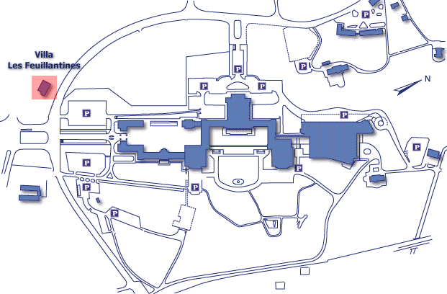
DOOR 6
NAVILLE
POSTE
BANK

SALLES
1 TO 3
H3 & F3
Entry for authorized persons only
on foot
Security ID
Section Entry
DOOR 40

SALLES
17 TO 27

XVII
TO
XXVII

DOOR 2
MEDICAL
SERVICE

SALLE
C3 & A-R

DOOR 20
BIBLIOTHEQUE
LIBRARY
VILLA
LE BOCAGE
DOOR 1 SAFI
LA PELOUSE

